Chapter 1 Rational Numbers
There are three containers P, Q, and R used to store rice. Their capacities are related as follows: Q is 3/4 of P R is 2/3 of Q.
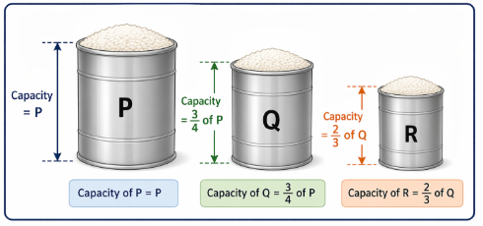

MCQs
- If the capacity of container P is 96 m³, what are the capacities of Q and R?
A. 72 m³ and 48 m³
B. 64 m³ and 48 m³
C. 72 m³ and 36 m³
D. 64 m³ and 36 m³
Answer: A

- What is the capacity of R in terms of P?
A. 1/2 of P
B. 1/3 of P
C. 1/4 of P
D. 3/4 of P
Answer: A

- If P = 120 m³, what is the difference between P and Q?
A. 20 m³
B. 25 m³
C. 30 m³
D. 40 m³
Answer: C

- Which of the following statements is correct?
A. Q = 2/3 P
B. R = 1/2 P
C. R = 3/4 P
D. Q = 1/2 P
Answer: B

- What is the ratio of capacities of Q and R?
A. 3 : 2
B. 2 : 3
C. 4 : 3
D. 3 : 4
Answer: A

